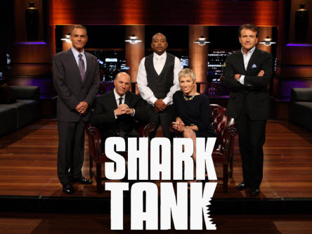

Shark Tank Project

To help apply your business mathematics knowledge and reflect on some of the items learned throughout the course you will create a product/invention. You will then present your plan to the class of “Sharks” who will evaluate and analyze your plan for strengths and weaknesses. Your presentation is due on May 20th and must consist of the following components.
Part A Investigate (10 points)
- You will identify a similar product and research the potential problem(s)/hazards of the product and the negative effects for consumers. Potential hazards could include:
o toxic building materials;
o ineffective, inefficient and/or dangerous manufacturing practices;
o ineffective, inefficient, and/or dangerous shipping practices;
o ineffective, inefficient, and/or dangerous waste disposal practices

- Select one item to problem-solve.

- Create a graphic organizer containing the following information:
o the problem (both the identification and explanation of);
o the design specifications (a list of requirements that the solution must have in
order to really solve the problem – this includes the information you learned from
your research);
o cited sources for all references used to determine the above information.
(A sample of your graphic organizer can be found on Mrs. Veldman’s Website – A – Investigate)

Part B Product Plan (14 points)
- Research materials to produce your product and supplier, cost, quantity, and resource for those materials. Assume you will sell at least 10,000 of your product.
- Research at least 5 comparable items to your product and find their cost per item. Include a resource for each item.
- List what you will sell your product for a justify why. Also calculate total markup and percent of markup for your item.
(A sample of your graphic organizer can be found on Mrs. Veldman’s Website – B – Element Cost Analysis)

Part C (80 points)
You are expected to construct a plan to create your chosen product/solution that has a series of logical steps, and that makes effective use of resources and time. You are expected to evaluate the plan and justify any modifications to the design throughout the process.
(A sample of your graphic organizer can be found on Mrs. Veldman’s Website – C – Business Plan)

Part D (52 points)
Your final task is to complete a presentation to share with the class. This presentation can either be a powerpoint with oral presentation or it can be a video/infomercial for the Sharks to view. Use the checklist to make sure you have necessary components.
(Oral Presentation – D – Checklist)
Part A – 5 points each section
Part B – 5 points each chart, 2, 1, 1
Part C – 1 point per question
Part D – 3 points per required element, 12 for rubric below
CATEGORY | 4 | 3 | 2 | 1
Content | Shows a full understanding of the topic. | Shows a good understanding of the topic. | Shows a good understanding of parts of the topic. | Does not seem to understand the topic very well.
Preparedness | Student is completely prepared and has obviously rehearsed. | Student seems pretty prepared but might have needed a couple more rehearsals. | The student is somewhat prepared, but it is clear that rehearsal was lacking. | Student does not seem at all prepared to present.
Evaluates Peers | Fills out peer evaluation completely and always gives scores based on the presentation rather than other factors (e.g., person is a close friend). | Fills out almost all of the peer evaluation and always gives scores based on the presentation rather than other factors (e.g., person is a close friend). | Fills out most of the peer evaluation and always gives scores based on the presentation rather than other factors (e.g., person is a close friend). | Fills out most of the peer evaluation but scoring appears to be biased.

