Whelk-Come to Mathematics
Why do you think crows consistently fly to a height of about 5 meters before dropping a whelk onto the rocks below?
The figure below left shows the possible flight paths of northwestern crows when they are dropping whelks. The figure below right shows the detail of a whelk, a large marine gastropod (snail) found in temperate waters.
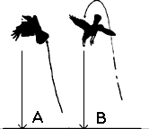 | 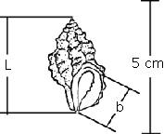

Consider the dropping of large whelks by northwestern crows.
- Which flight path, A or B, do you think the crows use most? Why?
- What factors do you think influence the height at which the crows choose to drop the whelk?
- Do you think there is a minimum or maximum number of drops required to break a whelk?
- Do you think there is a minimum or maximum height at which a whelk can be dropped to break?
- We are going to perform an experiment to model this action. Each group will collect and analyze data using peanuts as whelks.
  - First you will collect data for the height specified. You will need to drop your “whelk” eight times and average your number of drops to share with the class.
Height | Trial | 1 | 2 | 3 | 4 | 5 | 6 | 7 | 8 | Average
 | Number of Drops

Height | Trial | 1 | 2 | 3 | 4 | 5 | 6 | 7 | 8 | Average
 | Number of Drops
- Once the entire class has their data we are going to share data so that we can get an accurate equation for our situation.
Height of Drop | 8 | 10 | 12 | 14 | 16 | 18 | 20 | 22 | 24
Number of Drops
- Sketch a possible graph of the number of drops required to break a whelk as a function of the height of the drop on the graph below. Label your x and y axis.

- Does your graph appear to have any asymptotes? If so where?

- Come up with a model that could fit your data using your knowledge of hyperbolas and inverse functions.

- Do you think there is a minimum number of drops required to break open a peanut?

- Do you think there is a minimum height required to break open a peanut?

